Ministry of Education of the Republic of Belarus

Polessky State University

Economic Faculty

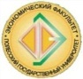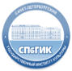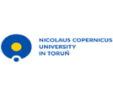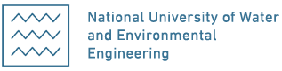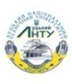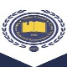

Belarusian National Technical University
Saint Petersburg State University of Culture
Nicolaus Copernicus University in Toruń
Adam Mickiewicz University in Poznan
National University of Water and Environmental Engineering, Rivne
Lutsk National Technical University
Odessa National Economic University

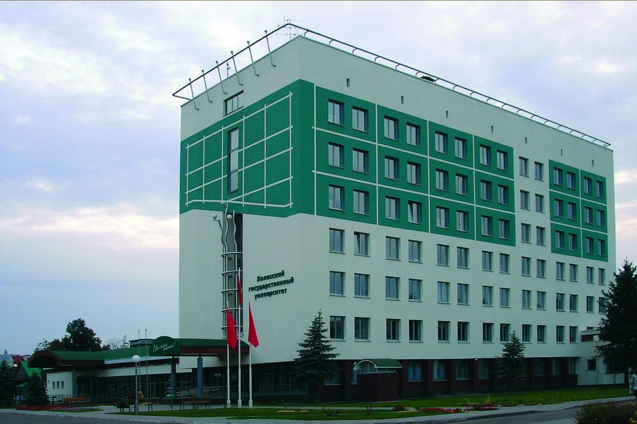

XIII International scientific conference

«SUSTAINABLE DEVELOPMENT OF ECONOMY: THE STATE,
PROBLEMS AND PROSPECTS»
April 26, 2019

Dear colleagues,
We invite you to participate in
the ХIIIth International scientific conference
“Sustainable development of economy: the state, problems and prospects”

The conference will focus on the following topics:

- Problems of economy’s sustainable development.
2. Development of Regional Complex Entrepreneurial Structures: Current Problems and
Solutions
3. Problems of marketing and management in innovative economy
4. Problems and tendencies in the sustainable development of tourism
5. Socio-humanitarian and legal problems of society modernization

The languages used in paper presentations and discussions are Belarusian, Russian, Ukrainian, Polish, English
Participants can present their reports either on plenary sessions (20 minutes) or on section sessions (10 minutes) or only publish their materials.
To participate in the conference authors should send their original papers and application forms to the Organizing Committee before March 31, 2019 ( E-mail: polessu.conf@mail.ru )

Submission guidelines
- MS WORD, an A4 page size. Submit no more than three (3) single-spaced pages.
- Times New Roman, 14 pt, single spaced, 2 cm margin on all four sides, new paragraph 0,5 cm.

Contact Information:
225710, Republic of Belarus
Brest region, Pinsk, Kulikova, 27 office 2308
Zhanna Shumak, Deputy Dean for Research, Economic Faculty
fax: +375 165 65 31 72, mobile +375 29 331 83 19
E-mail: polessu.conf.@mail.ru
Website: http://www.polessu.by/

